**PAYROLL ANALYSIS GUIDE:**

**1. Open the project folder:**



**2. Paste the files needed to be compared:**

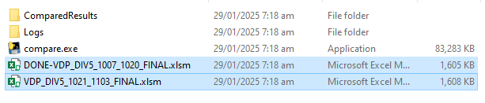

**3. Run ‘compare.exe’:**

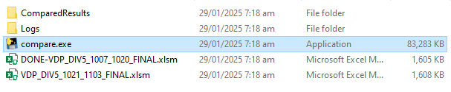

**Note:** Make sure that any files in this folder is not open when we run the application.

- Wait for a little while until the dialog box appears:

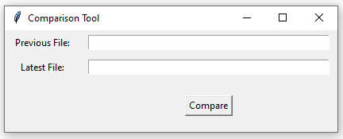

**4. Input the file name of the previous file and latest file:**

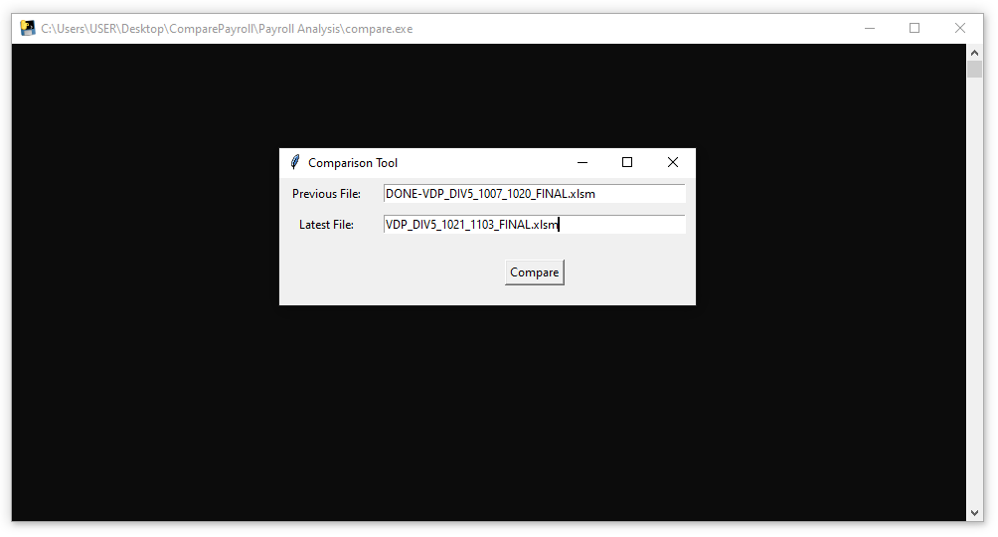

- After that, click “Compare”

- Wait until the application finished processing the files and it will automatically close.

**5. Check the results:**



- Open the “ComparedResults” folder and check the files located here:

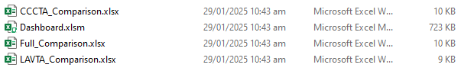

**Note:** Make sure that when running the application, do not delete **“Dashboard.xlsm”** as this is the template for the dashboard.

**5. Open “Dashboard.xlsm”**

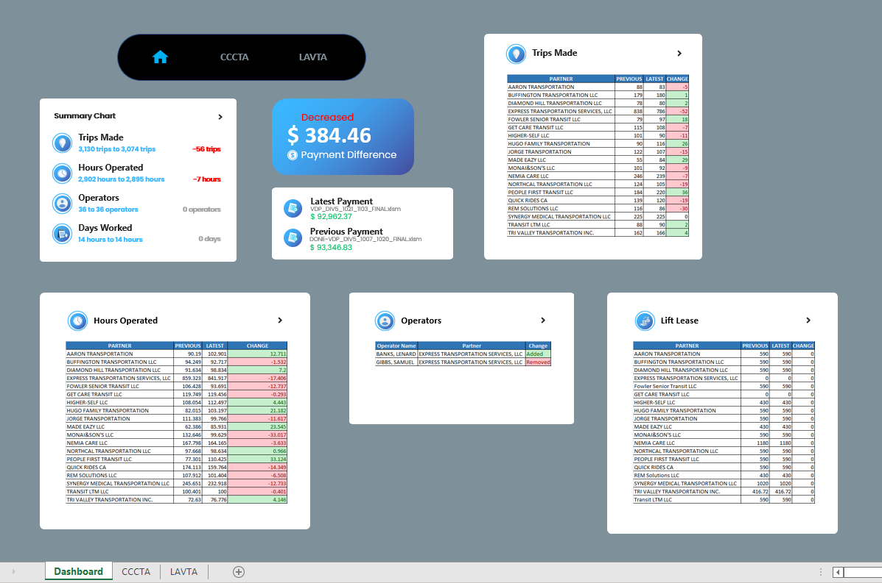

- This is how the dashboard looks.

- Each of the boxed fields can be clicked and will redirect you to their data source.

**Note:** Make sure that for the link to work on Dashboard, the following files must be present and not be deleted from the folder.

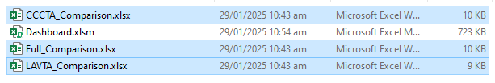

**Other Guides:**

**(1)**

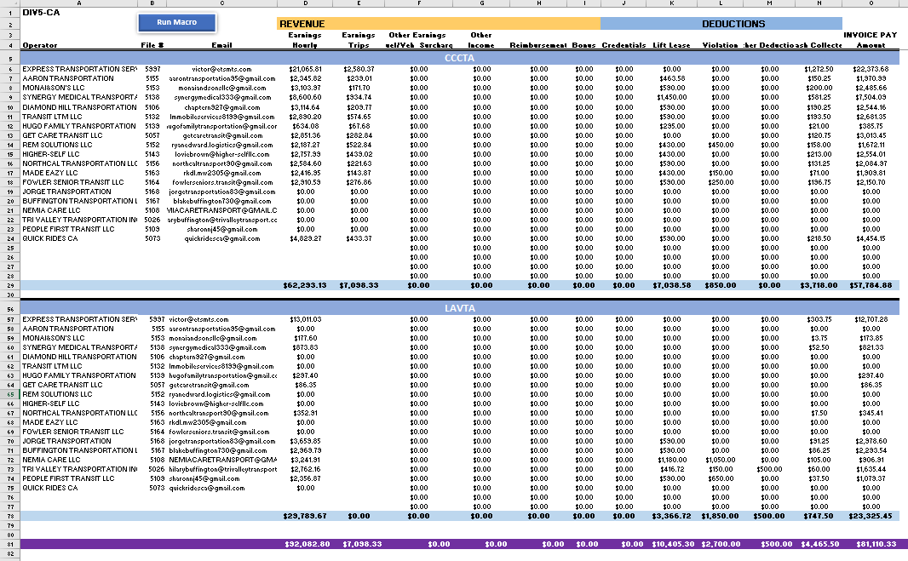For this program used in this set of files, it is needed for the total invoice payments for each client to be located on the following:

CCCTA - Row 29

LAVTA - Row 78

Total - Row 81

**(2)**

- If you encountered errors in the logs like if the pictures are incomplete in the dashboard, rerun the program.